**MODULE 1-4**

**1.** Install VirtualBox or VMware. Set up a virtual machine with any Linux distribution (preferably Kali Linux).

* **Screenshot Submission:** Screenshot of VirtualBox/VMware with the virtual machine running.

**Step 1:** Install virtual box on <https://www.virtualbox.org/>.

**Step 2:** Set kali Linux in virtual box we use add option.

**Step 3:** After the setup of Linux virtual box

**Step 4:** Click on the start button.

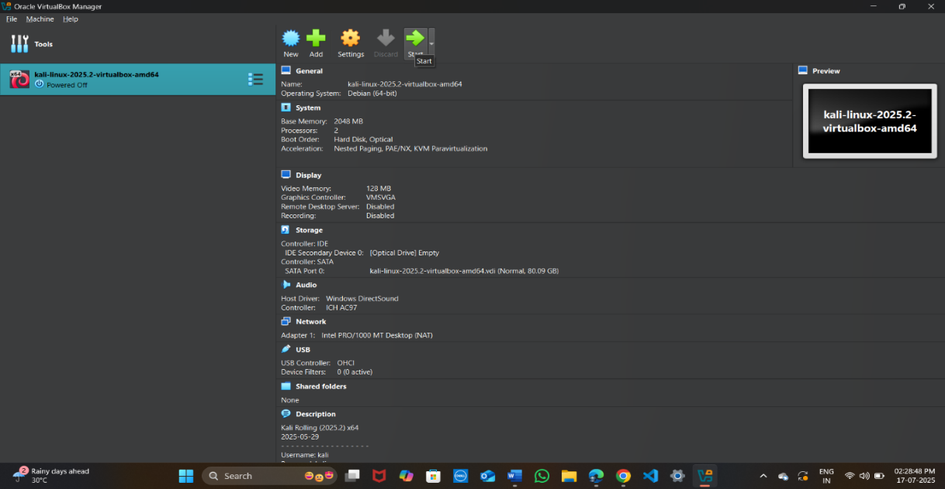

**2.**  Install Kali Linux in your virtual machine and update it.

* **Screenshot Submission:** Screenshot of the terminal showing the completion of the update.

🡪 kali install on this link [www.kali.org](http://www.kali.org)

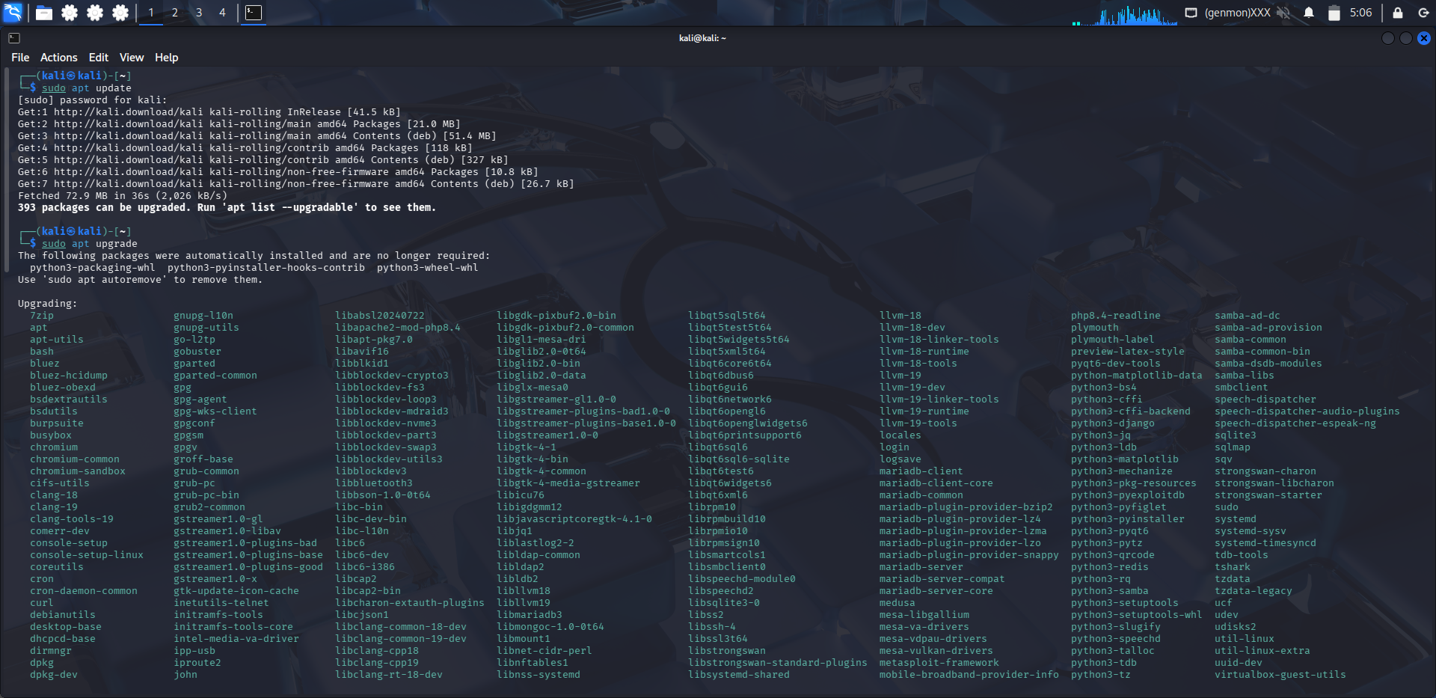

**3.** Explore the applications menu in Kali Linux. List 5 tools and their purpose.

* **Screenshot Submission:** Screenshot of the applications menu.

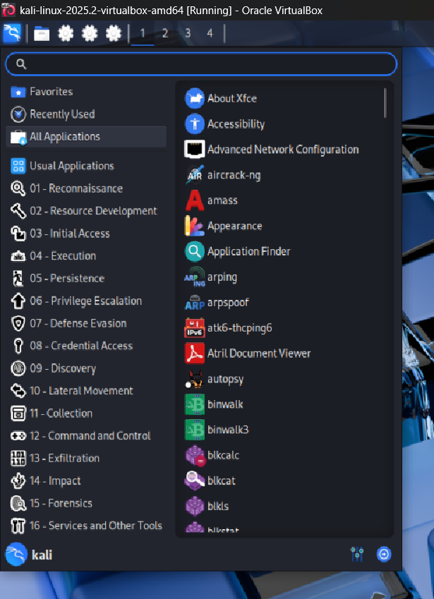

**1. aircrack-ng**

* **Purpose:** A powerful suite of tools for assessing Wi-Fi network security.
* **Usage:** Cracking WEP/WPA-PSK keys, packet capturing, and replay attacks.

**2. amass**

* **Purpose:** An advanced tool for **network mapping and attack surface discovery**.
* **Usage:** DNS enumeration, network infrastructure mapping, and OSINT gathering.

**3. arpspoof**

* **Purpose:** Part of the dsniff suite, used for **ARP spoofing/poisoning**.
* **Usage:** Redirect packets on a local network to facilitate man-in-the-middle (MitM) attacks.

**4. autopsy**

* **Purpose:** A **digital forensics platform** used for investigating hard drives and smartphones.
* **Usage:** Analyzing deleted files, browsing disk images, and examining file system metadata.

**5. binwalk**

* **Purpose:** A tool for **analyzing and extracting firmware images**.
* **Usage:** Reverse engineering embedded firmware by scanning for executable code, file systems, and compressed data.

**4.** Execute the following Linux commands:

* Find command
* Ping command
* Traceroute command
* Whoami command
* Ps command
* **Screenshot Submission:** Screenshot of terminal output for each command.

